Spirited Seas Renaissance Faire
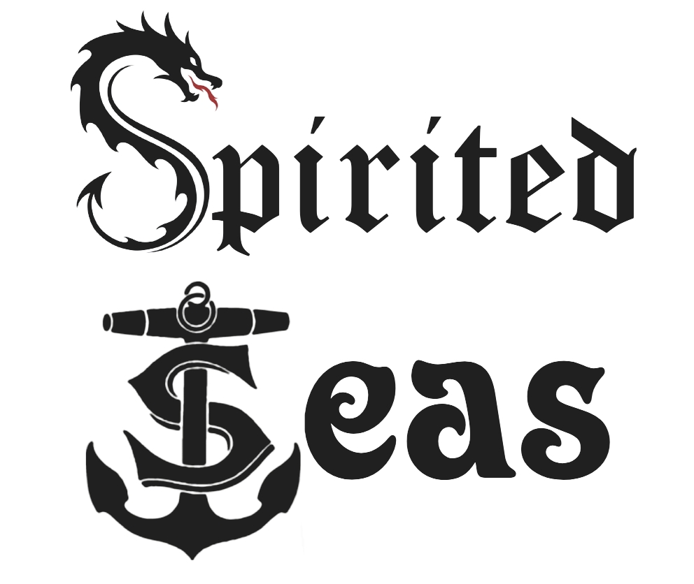
Mail to: Spirited Seas Renaissance Faire Inc. 5077 Mount Olivet Rd Kalamazoo, MI 49004
Saturday, August 7 10am-6pm and Sunday, August 8 10am- 6pm
Maple Island, Paw Paw MI
Council Member Application and Agreement Date: ________
Name: ______________________________________
Faire/Stage Name: _____________________________________
Address:______________________________________________________________________________
City: ___________________________ State: ________ Zip: ________
Email : ____________________________ Phone: ____________________________
Best time to call: _____________________________________
(Please use the back of this form or a separate sheet as necessary to answer the following questions:)
1. Why do you want to become a member of Spirited Seas Renaissance Faire Council?
2. What is your desired position? (Quartermaster, Knight/Surgeon, Boatswain, Princess, Governess, Tradesman, Coin Master, Guardian of the Forest, Baron/Baroness, Physic Artists, Innkeeper, Chamberlain, Pub Master, Sea Artists) _____________________________ Please use the back of this form to explain why you want this position and why we should consider you. For example: explain your ideas, past experiences and how you see yourself helping the Faire. (Some positions have already been filled. If you have an alternate position in mind, please also include information about that.)
3. Do you have any previous Renaissance/Fantasy Faire experience? Where? _____________________________ When? ________________________
4. Do you use illegal drugs or abuse alcohol? Have you ever been arrested for a Criminal offense? (Other than minor traffic violations?) Explain.
5. Have you ever been charged with abuse or neglect of a minor?
6. What are your hobbies/special interests? What clubs, organizations or other volunteer activities do you participate in?
7. What are your special skills, such as sewing ability, woodworking/carpentry, computer skills, acting, writing, sales, cooking, etc.? Use the back of this sheet for additional information.
8. The Faire is Saturday, August 7, 10am - 6 pm and Sunday, August 8, 10 am to 6 pm. Volunteers report at 9 am. Members of the Council are expected to be on-site for the entire event, including set-up and tear-down. If you are selected to work with us in this capacity and sign on, you are agreeing to this commitment. (Setup is Friday, August 6, 7 am - 9 pm and we need all hands-on deck if possible, hours are negotiable.)
9. Members of the Council are expected to fill in wherever needed to help make the faire a success. This means that, in addition to fulfilling your duties, you may be called upon to fill in a general volunteer role, until such time as a replacement can be found. There are many events that take place throughout the year to promote and raise money for The Spirited Seas Renaissance Faire. While dressed in garb, we hand out flyers and/ or entertain. We need your participation to make each event a success. For questions or more information, contact the Faire office Disclaimer: I understand that neither The Spirited Seas Renaissance Faire nor its affiliates will be held liable in the event of loss or damage before, during, or after festival hours. I also understand that by signing this contract I am, without payment to me or anyone helping me, granting The Spirited Seas Renaissance Faire the right to use for all promotional, educational and other purposes to promote the Festival any photo, video or other reproductions of any image in which we appear. Actions of Spirited Seas Renaissance Faire and its participants are for entertainment purposes only. ------------------------------------------------------------------------------------------------------------------------------
For Spirited Seas Administration use only: Date received: ________________
Position: __________________________________________________ _____
Approved by the Queen _____ Approved by the Captain (Please initial) ------------------------------
Approved by the Duchess
(Please do not write in this space until a position has been offered to you by The Spirited Seas Administration.
Council Member Agreement
I, ________________________________ (Applicant’s Name), agree to work together as a Council member of Spirited Seas Renaissance Faire, performing the duties of _______________________________ (as specified in the attached position description) until December 31, 2022. By signing below, I understand that this is a volunteer position with no monetary compensation. I understand and agree to uphold The Spirited Seas policies and procedures (found attached and in the Volunteer Information Packet) as they pertain to this position.
Name (please print): ____________________________________ Signed: ____________________________________ Date: __________
Thank you for agreeing to be a member of The Spirited Seas Renaissance Faire Executive Committee. WE SINCERELY APPRECIATE YOUR PARTICIPATION and will do everything we can to make your time with us enjoyable for everyone. Page 1 of 2 REV 10/25/19 Mail to: Spirited Seas Renaissance Faire Inc, 5077 Mount Olivet Rd, Kalamazoo, MI 49004. Saturday, August 7, 10 am - 6 pm and Sunday, August 8, 10 am - 6 pm Maple Island Paw Paw, MI

Council Member Roles and Duties
King/Queen (Founder 1)
The King/Queen shall attend all meetings and events, oversee all important decisions and votes made with the other owners. work closely with each individual council member to keep each member on task for Spirited Seas Renaissance Faire on schedule. Always be available for any concerns or questions any council member may have.
Captain (Founder 2)
The Captain shall attend all meetings and events, responsible for keeping the council on track during meetings, included in all decisions regarding finances, site, or other important decisions regarding Spirited Seas Renaissance Faire. Work closely with the King/Queen and Duchess in keeping the rest of the council on schedule for Spirited Seas Renaissance Faire.
Duchess (Founder 3)
The Duchess shall attend all meetings and events, an example of good leadership among the council, out in public and on social media. The Duchess will always maintain grace and elegance while involved with Spirited Seas Renaissance Faire. Included in all decisions regarding finances, site, or other important decisions regarding Spirited Seas Renaissance Faire. Work closely with the King/Queen and the Captain in keeping the other council members on schedule for Spirited Seas Renaissance Faire.

Quartermaster (Volunteer Coordinator)
The Quartermaster shall attend all meetings and events, recruit, organize and oversee all volunteers at Spirited Seas Renaissance Faire or related events, create a schedule for volunteers of (2) 4-hour work shifts. Volunteers may work 8 hours if they choose. Work with the King/Queen, Captain, Cook, Boatswain, Baron/Baroness, Guardian of the Forest to see where volunteers are needed. Make a detailed schedule for all volunteers for locations and times needed to be sure all locations are secure and filled. Be sure that all volunteers have a volunteer form filled out before volunteering begins at Spirited Seas Renaissance Faire or related events. Make sure all volunteers are following the policies and guidelines of the Spirited Seas Renaissance Faire.
Princess (Cast Coordinator)
The Princess shall attend all meetings and events, recruit, organize, train, and oversee all cast for lane interactions and stages at Spirited Seas Renaissance Faire or related events. Work with the Duchess and Knights to in training cast in emergency situations where extra volunteers are required and security needs assistance. The Princess along with the King/Queen, Captain and Duchess will all approve the costumes of the cast prior to Spirited Seas Renaissance Faire or related events. Inform the King/Queen, Captain and Duchess if cast is needed for any promotional events prior to Spirited Seas Renaissance Faire or related events. Have all cast fill out volunteer forms prior to Spirited Seas Renaissance Faire.
Boatswain (Entertainment Coordinator)
The Boatswain shall attend all meetings and events, recruit and organize the entertainment for Spirited Seas Renaissance Faire. Create an organized schedule for all acts including lanes, stage, pub, fight lists and other entertainment. Recruit local entertainment from around the community. Have all entertainment fill out the entertainment form and application before the entertainment performs at Spirited Seas Renaissance Faire. Work with the King/Queen, Captain, the Duchess, and Baron/Baroness to approve and determine where all entertainment will be placed at Spirited Seas Renaissance Faire.
Tradesman (Merchant/Vendor Coordinator)
The Tradesman shall attend all meetings and events, recruit and organize the merchant/vendor for Spirited Seas Renaissance Faire. Create a detailed map of where each merchant/vendor is located for guests to be to locate. Have all merchant/vendor fill out the forms and applications needed to be a merchant/vendor at Spirited Seas Renaissance Faire. Work with the King/Queen, Captain, the Duchess, and Baron/Baroness to help in the placement of each merchant/vendor at Spirited Seas Renaissance Faire. Recruit local merchant/vendor from the community to help raise awareness about the community and Spirited Seas Renaissance Faire.
Coin Master (Sponsorship/Fundraising Coordinator)
The Coin Master shall attend all meetings and events, recruit sponsors while following the guidelines of the sponsorship packet laid out. Work with the King/Queen, Captain, the Duchess and Physic Artists to gain sponsors and to promote on social media and around the community. Work with the King/Queen, Captain, and Duchess to help raise funds for any part of Spirited Seas Renaissance Faire. Acquire sponsors and funds using the correct forms laid out and in the Coin Master packet.
Physic Artists (Marketing/ Advertising Coordinator)
The Physic Artists shall attend all meetings and events, work with the King/Queen, Captain, the Duchess and Coin Master to help promote and advertise any sponsors the Coin Master acquires. Promote and advertise Spirited Seas Renaissance Faire in a positive way whether it be social media, public, or other events. Promote Spirited Seas Renaissance Faire following the marketing/advertising guidelines packet. Promote Spirited Seas Renaissance Faire with promotional events such as radio, flyers, tv spot, merchandise, promotional items, promotional events, and anything approved by the King/Queen, Captain, and Duchess.
Inn Keeper (Hospitality Coordinator)
The Inn Keeper shall attend all meetings and events, work with the King/Queen, Captain, the Duchess, and Chamberlain to make Spirited Seas Renaissance Faire as smooth and comfortable as possible for guests, merchants/vendors, volunteers, cast, Council, Knights and the community. Search out hotels around the community close to site as an alternative to weather for participants to stay at in case of storms, flooding, or bad weather during Spirited Seas Renaissance Faire. Work with the King/Queen, Captain, Duchess, Cook, Knights, Surgeon, Guardian of the Forest, Chamberlain, Baron/Baroness, to make a plan of what needs to be done on site to make the Spirited Seas Renaissance Faire run smoothly. Work with the Cook to get a budget for food for the Spirited Seas Renaissance Faire weekend for all participants. Keep a detailed account of all money spent in a money book for taxes. Will turn in all records at the end of Spirited Seas Renaissance Faire to either the King/Queen, Captain or Duchess. Keep all receipts from all purchases of anything bought for Spirited Seas Renaissance Faire. Plan a participant dinner on Saturday night of Spirited Seas Renaissance Faire to recognize the participants to thank them and the community.
Baron/ Baroness (Site Crew Coordinator)
The Baron/Baroness shall attend all meetings and events, work closely with the King/Queen, Captain, Duchess, Knight, Guardian of the Forest, Boatswain and Tradesman to figure out where everything should be set up. Make a detailed map of the site and decide where the best spots would be for the merchants/vendor and entertainment. Work closely with Guardian of the Forest to determine the best spot for camping during Spirited Seas Renaissance Faire. Help the King/Queen, Captain, Duchess search for new locations should one be needed for Spirited Seas Renaissance Faire. Make sure the site for Spirited Seas Renaissance Faire meets important guidelines that will be needed for faire i.e.; Plenty of shade, plenty of parking, electricity hook up, restrooms, kitchen area, easy to access from the road, and other criteria. Have the final say on location and where entertainment, camping, merchants/ vendors will be located besides the King/Queen, Captain, and Duchess.
Knight (Security Coordinator)
The Knight shall attend all meetings and events, work closely with the King/Queen, Captain, Duchess and Baron/Baroness to get an idea of how the site will be protected. Form a safety plan for emergencies and situations that could happen at Spirited Seas Renaissance Faire. Recruit other knights for Spirited Seas Renaissance Faire to help with securing the site. Recruit only knights that are professional, well mannered, have experience, reliable, trustworthy, and dependable. Have any knights fill out a volunteer form with the Quartermaster. Go over the safety plan with the King/Queen, Captain and Duchess after it is complete.
Surgeon (Medical Advisor)
The Surgeon shall attend all meetings and events, make a first aid kit for Spirited Seas Renaissance Faire. Make a list of any items needed for the first aid kit so the Council may get the supplies needed for Spirited Seas Renaissance Faire. Make a list of any required supplies needed for the Surgeon tent including a tent, first aid supplies, etc. Be sure to work closely with the Knight, Baron/Baroness, and Guardian of the Forest to make a safety plan for Spirited Seas Renaissance Faire. Be trained in first aid and have knowledge of other medical practices but is not required.
Governess (Children’s Activities Coordinator)
The Governess shall attend all meetings and events, plan activities for children of all ages to do at Spirited Seas Renaissance Faire. Make a list of supplies needed for any crafts, activities, or games for the Children’s area at Spirited Seas Renaissance Faire. Interact with the children and make the area a positive and fun experience for them during Spirited Seas Renaissance Faire hours. Be sure to make a set of guidelines for behavior for the Children’s area.
Guardian of the Forest (Camp Coordinator)
The Guardian of the Forest shall attend all meetings and events, work closely with the King/Queen, Captain, Duchess, Baron/Baroness, and Knight to determine the best plan for Spirited Seas Renaissance Faire. Make a map of the site and determine the best spot for camping at Spirited Seas Renaissance Faire. Work with the Baron/Baroness to determine the way to hide camp site from guests during Spirited Seas Renaissance Faire hours. Make sure the camp site reminds clean and picked up before, during and after Spirited Seas Renaissance Faire. Assign camping spots to any participant at Spirited Seas Renaissance Faire.
Chamberlain (Financial Advisor)
The Chamberlain shall attend all meetings and events, keep a detailed record of any expenses involving Spirited Seas Renaissance Faire. Work closely with the King/Queen, Captain, and Duchess monthly to keep up with the expenses of Spirited Seas Renaissance Faire. Turn in all expenses and records to the King/Queen, Captain or Duchess at the end of the Spirited Seas Renaissance Faire for taxes. Work closely with the Cook, Physic Artists, Coin Master, and Inn Keeper to determine when each will submit their expenses to the Chamberlain for record keeping. File the taxes at the end of fiscal year. Submit any changes to the IRS regarding Spirited Seas Renaissance Faire for tax purposes. Always be held accountable for anything regarding Spirited Seas Renaissance Faire including taxes, expenses, payments of entertainment, payment of merchants/vendors, payment of sponsors and advertising, and promotional expenses.
Pub Master (Pub Coordinator)
The Pub Master shall attend all meetings and events, oversee the set up and tear down of the Pub at Spirited Seas Renaissance Faire. Work closely with the King/Queen, Captain, Duchess and Chamberlain to plan, and oversee the running of the Pub. Oversee their own volunteers to run the Pub when the Pub Master cannot be present. Oversee talking to the local community and getting the licenses to run the Pub at Spirited Seas Renaissance Faire. Oversee providing their own product at the Pub during Spirited Seas Renaissance Faire hours and the participant dinner. Work with the Chamberlain to set appropriate price for product for Spirited Seas Renaissance Faire.
Sea Artist (Web Master Coordinator)
The Sea Artists shall attend all meetings and events, work closely with the King/Queen, Captain, and Duchess to set up a website for Spirited Seas Renaissance Faire. Update and main the Spirited Seas Renaissance Faire website on a weekly basis to include upcoming events, promotional deals, updates, etc. Set up media accounts such as Facebook, Instagram, Twitter, and other outlets to help spread the word of Spirited Seas Renaissance Faire. Take pictures to put on the website at promotional events, non-promotional events, and Spirited Seas Renaissance Faire itself. Sight and tag people and places in pictures and posts to help promote Spirited Seas Renaissance Faire.

Page 6 of 6 Signature: ___________________________________________ Date: ___________

